2026 Winter Series- Lake Alfred FL
Page 1 of 3

East Coast Watercross

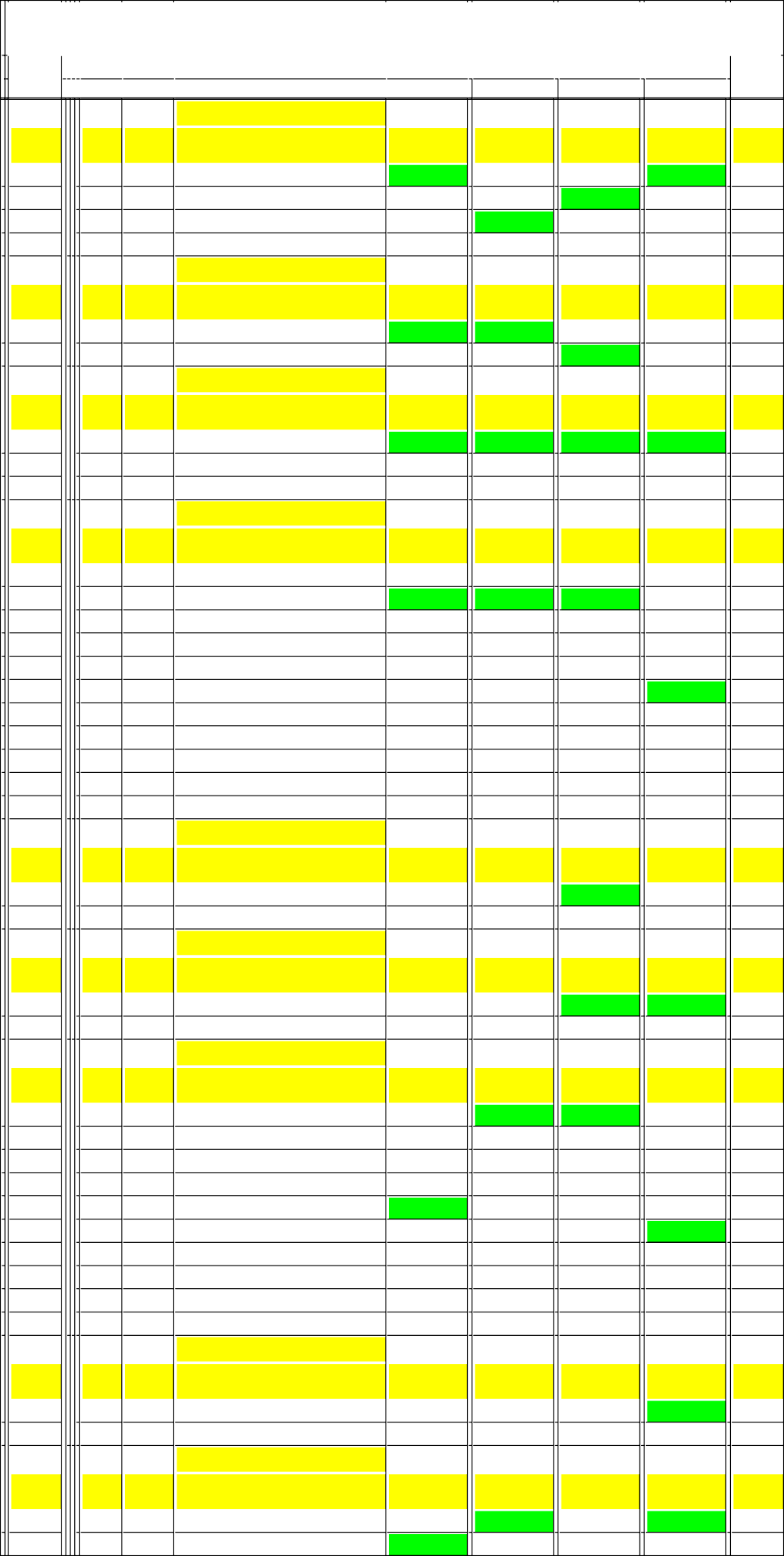

Place
1
2
3
4

Place
1
2

Place
1
2
3

Place
1
2
3
4
5
6
7
8
9
10
11

Place
1
2

Place
1
2

Place
1
2
3
4
5
6
7
8
9
10

Place
1
2

Place
1
2

Make KAW KAW KAW KAW

Make DOO DOO

Make OTH YAM YAM

Make DOO DOO YAM KAW DOO YAM OTH DOO YAM YAM KAW

Make KAW KAW

Make YAM KAW

Make KAW YAM YAM OTH KAW OTH OTH KAW YAM DOO

Make OTH OTH

Make DOO DOO

Racing Nbr
7
710
111
55

Racing Nbr
201
110

Racing Nbr
14
23
23

Racing Nbr
0
110
146
7
321
995
21
429
128
23
55

Racing Nbr
1
2

Racing Nbr
91
220

Racing Nbr
1
98
5
79
27
110
804
777
23
201

Racing Nbr
28
321

Racing Nbr
427
197

Pro/Am X2 Open

Name
Kayla Pliszka Andrew Freeman Warren Burke Kirsten Hasty
Pro/am Sport GP

Name
Massimo Casarini Tory Snyder
Junior Sport Spec

Name
Bryson Dill Cameron Spooner Janio Bermudez
Pro/ Am Sport Spec

Name
Arthur Catoira Tory Snyder Morgan Allen Kayla Pliszka James Hill Jax Rowe Haley Smith Peter Dickson Kyle Lizzi
Janio Bermudez Kirsten Hasty
Vintage Ski 550

Name Kylie Meier Joe Meier
Vintage Ski Open

Name Callan Landry Ryan Stevens
Pro/am Ski Stock

Name
Kylie Meier Shelby Warman Thomas Lambert Stefano Attianese Davi Prado Treyton Smith Tim Forinash Anna Glennon Janio Bermudez Massimo Casarini
ro/Am Runabout 1100 Limite

Name James Wright James Devlin
Nov Runabout 1100 Limited

Name
Brody Sebben Susan Zipkin
02/21/2026

Overall Finish
1
2
3
4

Overall Finish
1

Overall Finish
1

2

Overall Finish
2
1
3
4
6
89

5

Overall Finish

Overall Finish

Overall Finish
3
4
5
6
1

2

Overall Finish

Overall Finish
2
1
02/22/2026

Overall Finish
3
2
1

Overall Finish
1

Overall Finish
1

Overall Finish
2
1
3
4

89

5

Overall Finish

Overall Finish

Overall Finish
1
5
4
6
2

3
7

Overall Finish

Overall Finish
1
2
02/28/2026

Overall Finish
2
1

Overall Finish

1

Overall Finish
1
2

Overall Finish
4
1
7
5
6
2
3
8
9
10

Overall Finish
1
2

Overall Finish
1
2

Overall Finish
1
2
3
4

6
5

Overall Finish

89

Overall Finish
2
3
03/01/2026

Overall Finish
1
2

Overall Finish

Overall Finish
1
2

Overall Finish
7

6
5
4
1
3
9
2
8

Overall Finish

Overall Finish
1
89

Overall Finish
2
3
4
6

1
5

Overall Finish
1
89

Overall Finish
1
3

Total Points
221
219
108
43

Total Points
120
60

Total Points
240
106
53

Total Points
182
180
165
164
115
113
96
96
80
54
39

Total Points
60
53

Total Points
120
53

Total Points
221
183
173
151
113
96
78
53
48
33

Total Points
60
0

Total Points
226
209

2026 Winter Series- Lake Alfred FL
Page 2 of 3

East Coast Watercross
 |  |  |  | 02/21/2026 | 02/22/2026 | 02/28/2026 | 03/01/2026
 |  |  | Nov Runabout 1100 Limited
 |  | Racing |  | Overall | Overall | Overall | Overall | Total
Place | Make | Nbr | Name | Finish | Finish | Finish | Finish | Points
3 | DOO | 317 | Kyle Brockschmidt |  |  | 1 | 2 | 113
4 | DOO | 750 | Alan Postlewaite |  |  | 89 | 4 | 43
 |  |  | Pro/am Runabout 1100 Open
 |  | Racing |  | Overall | Overall | Overall | Overall | Total
Place | Make | Nbr | Name | Finish | Finish | Finish | Finish | Points
1 | DOO | 11 | Scott Borowy | 1 | 2 | 1 | 1 | 233
2 | DOO | 19 | Craig Squier | 2 | 1 | 2 |  | 166
3 | DOO | 9 | Cory Dickson |  |  | 4 | 2 | 96
4 | YAM | 23 | Janio Bermudez |  |  |  | 3 | 48
5 | DOO | 7 | Troy Morgan |  |  | 3 |  | 48
 |  |  | Novice Runabout 4 Stroke
 |  | Racing |  | Overall | Overall | Overall | Overall | Total
Place | Make | Nbr | Name | Finish | Finish | Finish | Finish | Points
1 | DOO | 0 | Arthur Catoira | 1 | 1 | 2 | 1 | 233
2 | YAM | 117 | Andy Martinez |  |  | 1 | 2 | 113
3 | YAM | 11 | Kyle Jackson | 2 | 2 |  |  | 106
4 | DOO | 777 | Billy Tew | 3 | 3 |  |  | 96
 |  |  | Pro/am Runabout 4 Stroke
 |  | Racing |  | Overall | Overall | Overall | Overall | Total
Place | Make | Nbr | Name | Finish | Finish | Finish | Finish | Points
1 | DOO | 606 | Alex Dobson | 3 | 6 | 4 | 1 | 187
2 | OTH | 529 | Marcio Benedetti | 5 | 5 | 5 | 3 | 165
3 | DOO | 110 | Tory Snyder | 1 | 3 | 2 |  | 161
4 | YAM | 281 | Armando Martinez |  |  | 1 | 2 | 113
5 | DOO | 224 | Carson Petersen | 2 | 2 |  |  | 106
6 | DOO | 201 | Massimo Casarini | 7 | 1 |  |  | 93
7 | DOO | 20 | Martin Bysiewicz | 4 | 4 |  |  | 86
8 | YAM | 123 | Michael Starace | 6 | 7 |  |  | 69
9 | DOO | 239 | Bobby Cardone | 8 | 9 |  |  | 57
10 | KAW | 27 | Davi Prado |  |  | 3 | 89 | 48
11 | YAM | 11 | Cline Glidden Iii |  | 8 |  |  | 30
 |  |  | Superchicken
 |  | Racing |  | Overall | Overall | Overall | Overall | Total
Place | Make | Nbr | Name | Finish | Finish | Finish | Finish | Points
1 | DOO | 197 | Susan Zipkin | 1 | 1 | 2 | 2 | 226
2 | KAW | 88 | Tully Zipkin | 2 | 2 | 1 | 1 | 226
 |  |  | Junior Ski 10-12
 |  | Racing |  | Overall | Overall | Overall | Overall | Total
Place | Make | Nbr | Name | Finish | Finish | Finish | Finish | Points
1 | YAM | 33 | Cash Mcclure |  |  | 1 | 1 | 120
2 | OTH | 94 | Charlie Adams |  |  | 2 | 2 | 106
3 | YAM | 114 | Brayden Dill |  |  | 3 | 3 | 96
 |  |  | Pro/Am WX1050
 |  | Racing |  | Overall | Overall | Overall | Overall | Total
Place | Make | Nbr | Name | Finish | Finish | Finish | Finish | Points
1 | KAW | 1 | Kylie Meier |  |  | 1 | 3 | 108
2 | YAM | 995 | Jax Rowe |  | 0 | 3 | 2 | 101
3 | YAM | 88 | Brad Adams |  |  | 2 | 4 | 96
4 | KAW | 316 | Austin Jones |  |  | 4 | 5 | 82
5 | YAM | 151 | Hans Neel |  |  | 5 | 7 | 72
6 | YAM | 18 | Jason Forinash |  |  | 8 | 8 | 60
7 | YAM | 380 | Ben Dressel |  |  |  | 1 | 60
8 | YAM | 312 | Keith Dressel |  |  | 6 | 89 | 36
9 | YAM | 331 | Joe Lyons |  |  |  | 6 | 36
10 | KAW | 220 | Ryan Stevens |  |  | 7 | 89 | 33
11 | KAW | 15 | Kelly Neel |  |  | 9 |  | 27
12 | KAW | 710 | Andrew Freeman |  |  |  | 9 | 27
 |  |  | Junior FS Ski lites 10-12
 |  | Racing |  | Overall | Overall | Overall | Overall | Total
Place | Make | Nbr | Name | Finish | Finish | Finish | Finish | Points
1 | YAM | 33 | Cash Mcclure | 2 | 2 | 1 | 1 | 226
2 | YAM | 114 | Brayden Dill | 5 | 4 | 2 | 2 | 188

2026 Winter Series- Lake Alfred FL
Page 3 of 3

East Coast Watercross
 |  |  |  | 02/21/2026 | 02/22/2026 | 02/28/2026 | 03/01/2026
 |  |  | Junior FS Ski lites 10-12
 |  | Racing |  | Overall | Overall | Overall | Overall | Total
Place | Make | Nbr | Name | Finish | Finish | Finish | Finish | Points
3 | YAM | 23 | Cameron Spooner | 1 | 1 |  |  | 120
4 | YAM | 132 | Logan Fleming | 3 | 3 |  |  | 96
5 | YAM | 595 | Sebastian Wilcox | 4 | 5 |  |  | 82
6 | OTH | 94 | Charlie Adams |  |  | 3 |  | 48
 |  |  | Junior ski 13-15
 |  | Racing |  | Overall | Overall | Overall | Overall | Total
Place | Make | Nbr | Name | Finish | Finish | Finish | Finish | Points
1 | YAM | 23 | Cameron Spooner |  |  | 1 | 1 | 120
2 | YAM | 132 | Logan Fleming |  |  | 2 | 2 | 106
3 | OTH | 33x | Bentley Cox |  |  | 3 | 3 | 96
4 | YAM | 124 | Guyver Santucci |  |  | 4 | 4 | 86
5 | YAM | 151 | Andie Neel |  |  | 5 | 5 | 78
6 | KAW | 213 | Ellie Stevens |  |  | 6 | 6 | 72
 |  |  | Junior Four Stroke SKi Lites
 |  | Racing |  | Overall | Overall | Overall | Overall | Total
Place | Make | Nbr | Name | Finish | Finish | Finish | Finish | Points
1 | YAM | 23 | Cameron Spooner | 1 | 1 | 1 | 1 | 240
2 | YAM | 595 | Sebastian Wilcox | 6 | 3 | 3 | 2 | 185
3 | YAM | 132 | Logan Fleming | 3 | 4 | 4 | 4 | 177
4 | YAM | 33 | Cash Mcclure | 2 | 2 |  |  | 106
5 | OTH | 33x | Bentley Cox |  |  | 2 | 3 | 101
6 | YAM | 201 | Vittorio Casarini | 4 | 5 |  |  | 82
7 | YAM | 124 | Guyver Santucci |  |  | 5 | 5 | 78
8 | YAM | 114 | Brayden Dill | 5 | 6 |  |  | 75
 |  |  | Womens Runabout stock
 |  | Racing |  | Overall | Overall | Overall | Overall | Total
Place | Make | Nbr | Name | Finish | Finish | Finish | Finish | Points
1 | YAM | 11 | Skylar Ramgeet | 2 | 1 |  |  | 113
2 | YAM | 98 | Shelby Warman | 1 | 2 |  |  | 113
3 | DOO | 239 | Kristen Grzegorczyk | 88 |  |  |  | 48
 |  |  | Pro/am Ski Lites
 |  | Racing |  | Overall | Overall | Overall | Overall | Total
Place | Make | Nbr | Name | Finish | Finish | Finish | Finish | Points
1 | KAW | 1 | Kylie Meier | 1 | 1 |  |  | 120
2 | KOM | 595 | Kelly Wilcox | 2 | 2 |  |  | 106
3 | YAM | 995 | Jax Rowe | 88 | 89 |  |  | 48
 |  |  | Pro/Am 4 Stroke Ski Lites
 |  | Racing |  | Overall | Overall | Overall | Overall | Total
Place | Make | Nbr | Name | Finish | Finish | Finish | Finish | Points
1 | OTH | 710 | Kyla Desrosiers | 2 | 1 |  |  | 113
2 | YAM | 595 | Sebastian Wilcox |  |  | 3 | 1 | 108
3 | DOO | 201 | Massimo Casarini | 1 |  |  |  | 60
4 | YAM | 380 | Ben Dressel |  |  | 1 |  | 60
5 | YAM | 331 | Joe Lyons |  |  | 2 |  | 53
6 | YAM | 995 | Jax Rowe |  |  | 4 |  | 43
7 | DOO | 325 | Craig Savage | 89 |  |  |  | 0
 |  |  | Pro/Am Ski GP
 |  | Racing |  | Overall | Overall | Overall | Overall | Total
Place | Make | Nbr | Name | Finish | Finish | Finish | Finish | Points
1 | OTH | 201 | Christopher Landis | 1 | 3 | 1 | 1 | 228
2 | FST | 51 | David Cabrera | 2 | 5 | 5 | 2 | 184
3 | FST | 169 | Isabella Parker | 3 | 9 | 2 | 6 | 164
4 | KOM | 98 | Eric Medlin | 5 | 4 | 3 | 7 | 163
5 | KOM | 730 | Brayden Sebben | 10 | 2 | 6 | 3 | 161
6 | FST | 591 | Kyle Fabbro | 4 | 8 | 4 | 5 | 155
7 | KAW | 27 | Davi Prado | 9 | 1 | 10 | 4 | 154
8 | OTH | 24 | Charles Guinchard | 6 | 6 | 8 | 8 | 132
9 | KOM | 114 | Shawn Dudek | 8 | 7 | 7 | 10 | 120
10 | KOM | 595 | Kelly Wilcox |  |  | 9 | 9 | 54
11 | OTH | 28 | James Wright | 7 |  |  |  | 33
12 | FST | 187 | Derek Mroski | 88 | 89 |  |  | 22

