STARTING PROCEDURE

2 card is held up at tower :
•Holders raise your racer, racers start your engines!
•Tower will go down the line individually to each racer. Racer must nod, acknowledging they are ready. Tower will not proceed until racer has acknowledged.
•Now is the time to call a 2-minute hold if you need it. Once the card goes to 1, the starting procedure will not be stopped. No exceptions.

1 card in vertical position :
•All racers have acknowledged the tower, card changes from 2 to 1.
•Holders should be lowering racers into water, racers should be watching tower card and throttling up.

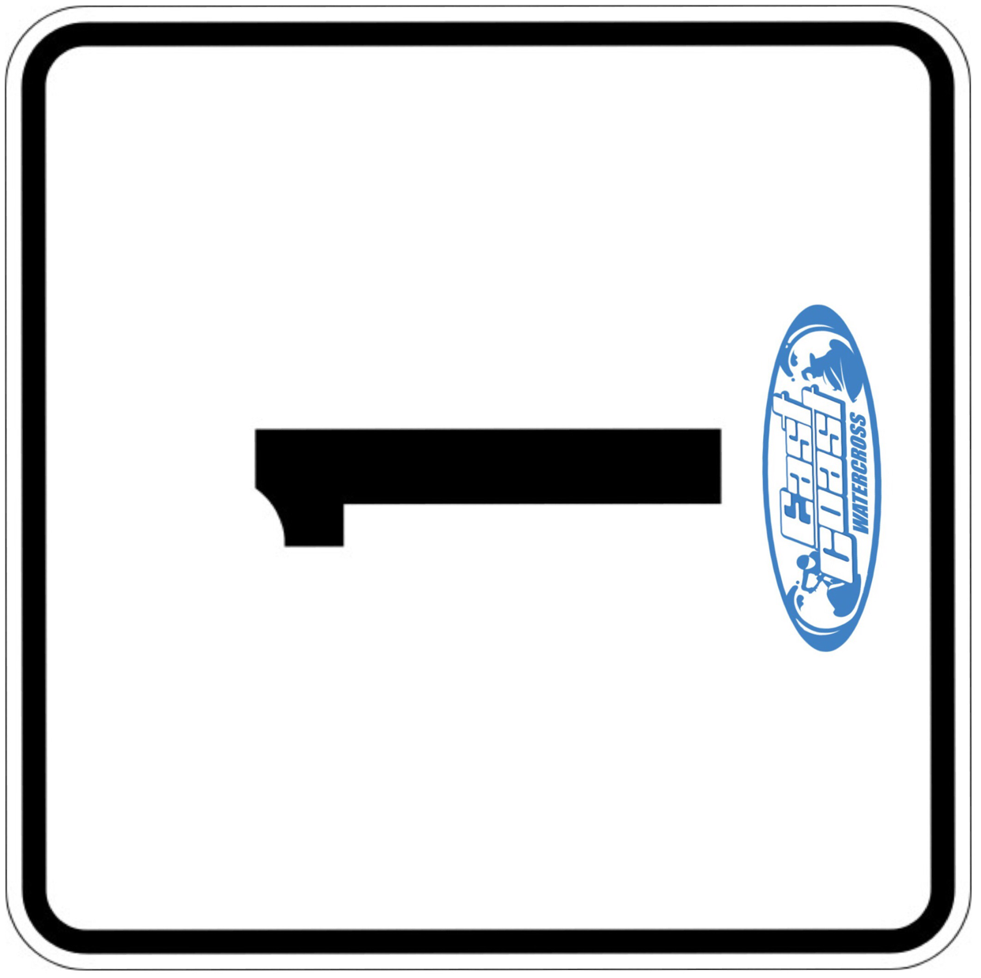

1 card in horizontal position :
•Card will go from vertical, to horizontal within 5 seconds.
•Racers WATCH THE BAND!!!
•Starter at gate will trip the band 3-7 seconds, after the 1 card is horizontal.
*note - band will NEVER be tripped as soon as the card goes horizontal! You go ON THE BAND, not the card.*

